Jenkins-03.

Jenkins-Clone-SonarQube-Integration

1. Create one Jenkins job using the below code and create three stages.
- stage1: Git clone to download the source code.
- stage2: Sonarqube Integration to check the quality of code.
- stage3: Slack Integration to send the alerts to slack.
Source Code: https://github.com/betawins/VProfile-1.git
Your architecture will be:
GitHub
|
| Stage 1 - Clone
v
Jenkins
|
| Stage 2 - SonarQube Analysis
v
SonarQube
|
v
Code Quality Report

Objective:
To configure Jenkins to clone/download the source code from the GitHub repository as the first stage of the CI pipeline.
Configuration Steps
- Created a new Jenkins Pipeline job named:
vprofile-sonarqube-slack
- Selected Pipeline script under the Pipeline section.
- Configured the Jenkins pipeline to run on the Built-In Node.
- Added the Git Clone stage.
- Configured the GitHub repository URL:
https://github.com/betawins/VProfile-1.git
- Saved the pipeline configuration.
- Clicked Build Now to execute the pipeline.
- Jenkins successfully connected to GitHub and cloned the repository.
- Jenkins checked out the master branch and the required commit.
- Verified the result in Console Output.
Stage 1 Pipeline Code
stage('Git Clone') {
steps {
git 'https://github.com/betawins/VProfile-1.git'
}
}
Observations
- Git was successfully available on the Jenkins node.
- Jenkins cloned the repository without requiring credentials because the repository is accessible publicly.
- The source code was downloaded into the Jenkins workspace:
/var/lib/jenkins/workspace/vprofile-sonarqube-slack
- The build completed with:
Finished: SUCCESS
Stage 1 — Git Clone is successfully completed.
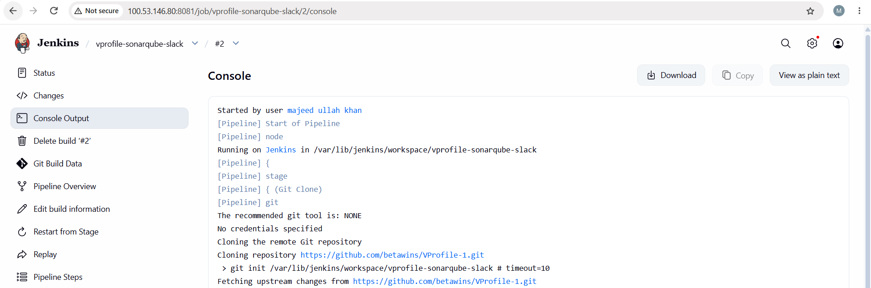
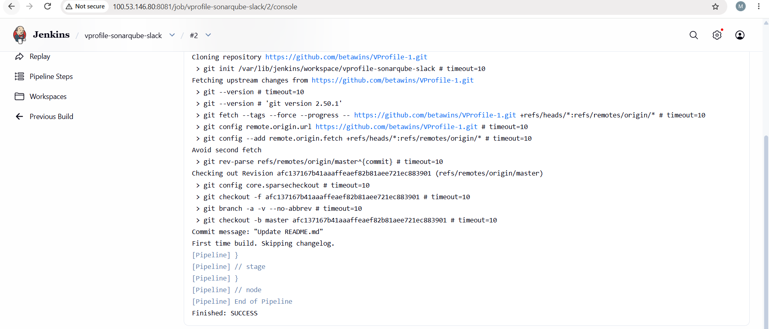

stage2: Sonarqube Integration to check the quality of code.
Server | Public IP | Type | Purpose
Jenkins | 3.85.102.210 | t3.micro | CI/CD
SonarQube | 3.91.207.184 | c7i-flex.large | Code quality analysis

ERROR: HTTP 403 by using this
sudo wget -O sonarqube.zip "https://binaries.sonarsource.com/CommercialDistribution/sonarqube/sonarqube-2026.1.6.131977.zip"
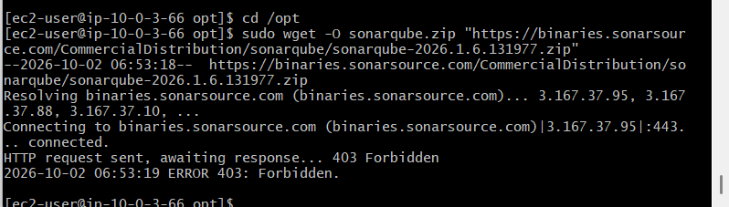
Fix the above error by Change to new version of zip.
------------------------------------------------------------------------------------------------------------
Errro: 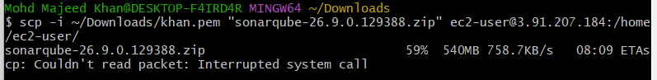
Fix it as: remove from differen terminal by using this command rm -f ~/sonarqube-26.9.0.129388.zip and reuplod sonarqube zip in another terminal to reach 100%
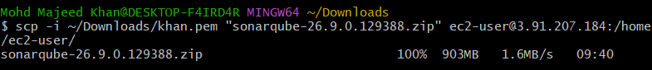
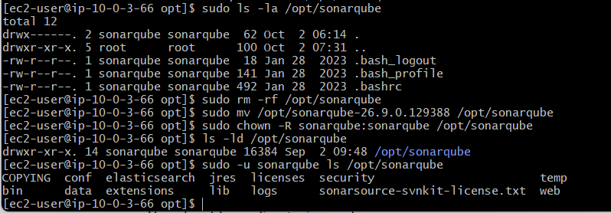
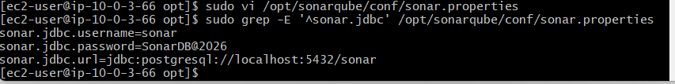
ERROR: Failed to locate executable /opt/sonarqube/bin/linux-x86-64/sonar.sh: Permission denied
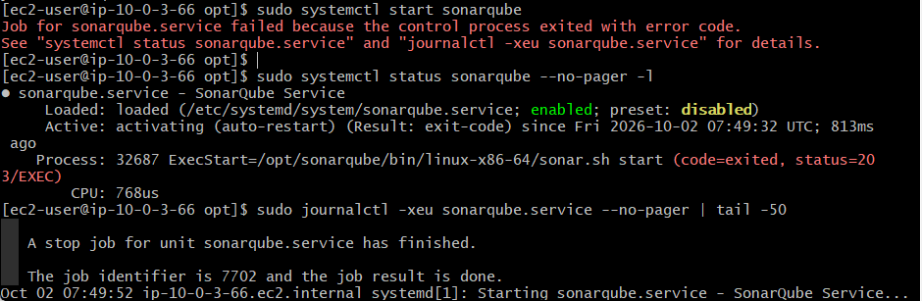
Current permission is: -rw-r--r--
Verify issue: There is no x (execute) permission, so systemd cannot run sonar.sh.
Fix it by Add execute permission
Run: sudo chmod +x /opt/sonarqube/bin/linux-x86-64/sonar.sh
Fix SS : 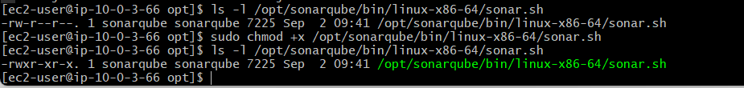
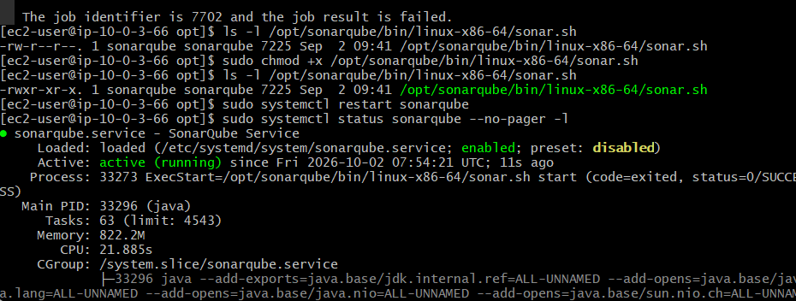
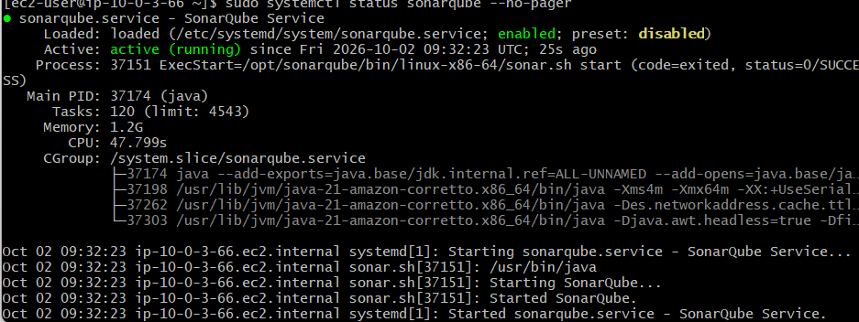
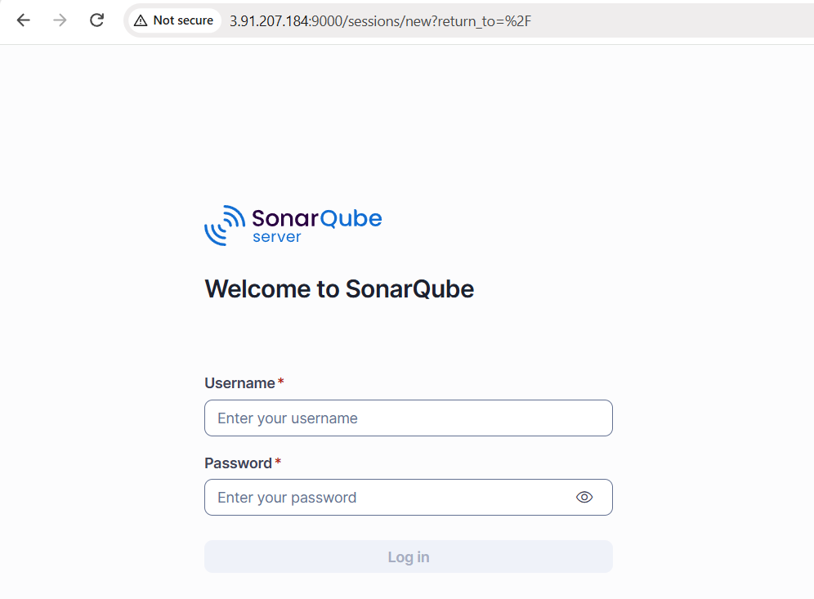

Error: What is causing it?
Your project uses this very old Maven plugin:
maven-war-plugin:2.2
Your Jenkins server is using:
Java 17
Maven 3.8.4
maven-war-plugin 2.2 is too old for this Java environment and causes:
Cannot access defaults field of Properties
So SonarQube analysis never started:
Stage "SonarQube Analysis" skipped due to earlier failure(s)

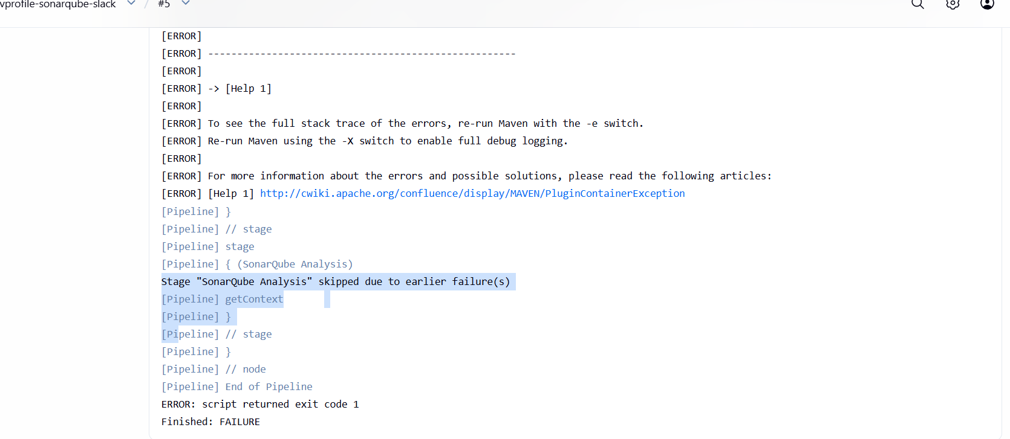
Let's fix the project build first
We should not change your Jenkins Java installation. Java 17 is fine.
We need to update the old maven-war-plugin version in the project's pom.xml.

Maven build is now successful.
The important confirmation is:
[INFO] Building war: .../target/vprofile-v2.war
[INFO] BUILD SUCCESS
So we successfully fixed the Java 17 compatibility issue by adding maven-war-plugin 3.4.0.
Next step: Run Jenkins Build #4
-------------------------------------------------------------------------------------------------------------
stage2: Sonarqube Integration to check the quality of code.
Copy the ZIP to SonarQube EC2
Keep your SonarQube SSH terminal open.
From your Windows Git Bash terminal in ~/Downloads, run:
scp -i "khan.pem" "sonarqube-26.9.0.129388 (2).zip" ec2-user@ec2-3-88-194-195.compute-1.amazonaws.com:/tmp/
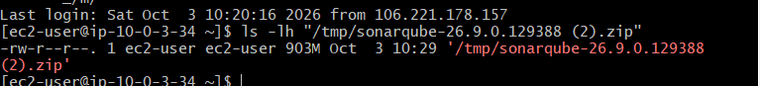
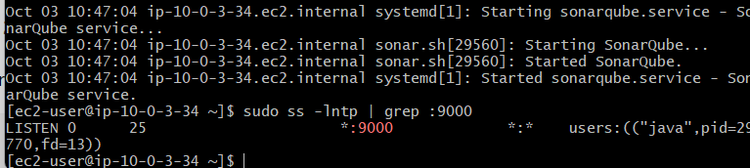
Task: Install and Configure SonarScanner CLI
Objective
To install and configure SonarScanner CLI on the Jenkins/Amazon Linux EC2 server for performing SonarQube code analysis.
Configuration Steps
1. Install Unzip
Installed the unzip package required to extract the SonarScanner ZIP file.
sudo yum install unzip -y
2. Download SonarScanner
Downloaded the SonarScanner CLI ZIP package.
wget https://binaries.sonarsource.com/Distribution/sonar-scanner-cli/sonar-scanner-cli-6.2.1.4610-linux-x64.zip
3. Verify the ZIP File
Checked the downloaded file:
ls
The following file was available:
sonar-scanner-cli-6.2.1.4610-linux-x64.zip
4. Extract SonarScanner
Extracted the ZIP package:
unzip sonar-scanner-cli-6.2.1.4610-linux-x64.zip
This created:
sonar-scanner-6.2.1.4610-linux-x64
5. Move SonarScanner to /opt
Moved and renamed the extracted directory:
sudo mv sonar-scanner-6.2.1.4610-linux-x64 sonar-scanner
Verified the installation directory:
cd /opt
ls
Output included:
aws
sonar-scanner
sonar-scanner-cli-6.2.1.4610-linux-x64.zip
Therefore, the SonarScanner installation directory is:
/opt/sonar-scanner
6. Verify SonarScanner Configuration Directory
Navigated to the configuration directory:
cd /opt/sonar-scanner/conf
Verified the configuration file:
ls
Output:
sonar-scanner.properties
7. Configure SonarScanner
Opened the configuration file:
vi /opt/sonar-scanner/conf/sonar-scanner.properties
Configured the required SonarQube server information in the properties file.
8. Verify Jenkins Service
Checked the Jenkins service:
systemctl status jenkins
Jenkins was confirmed to be:
Active: active (running)
Jenkins was running on:
Port: 8081

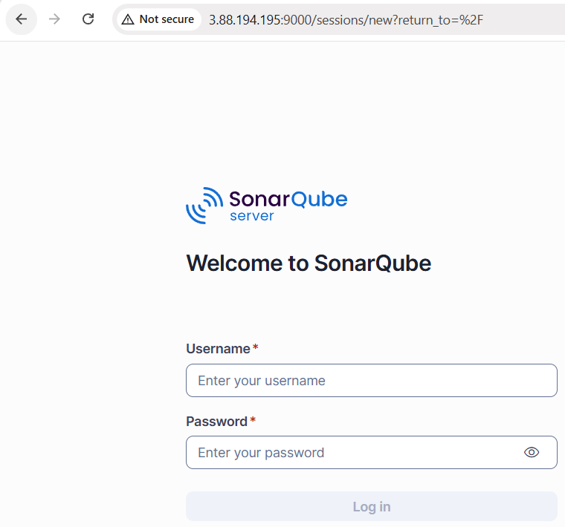
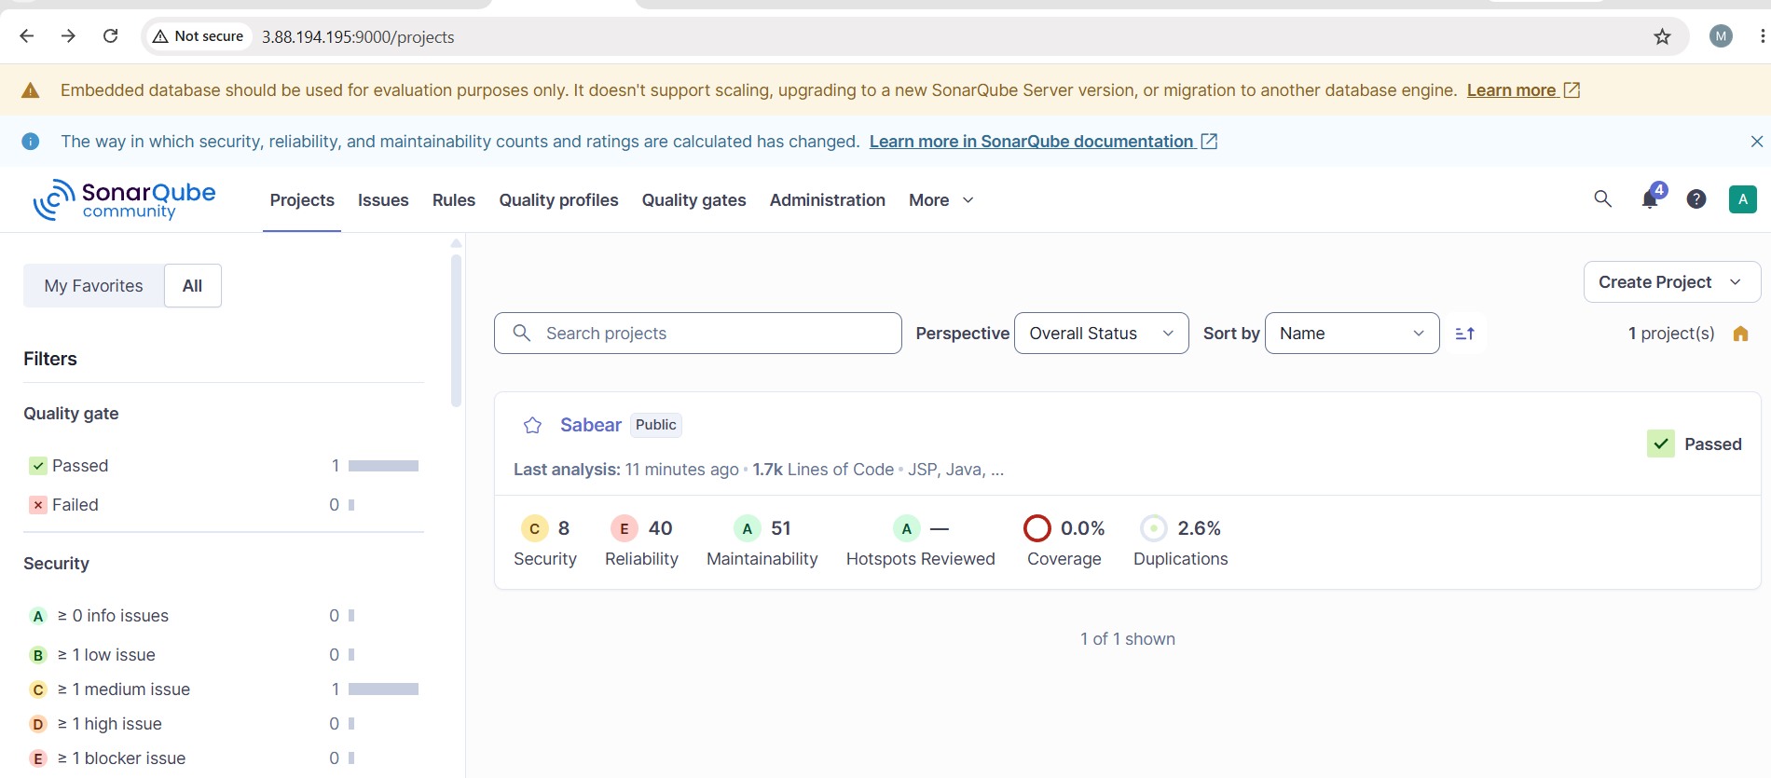

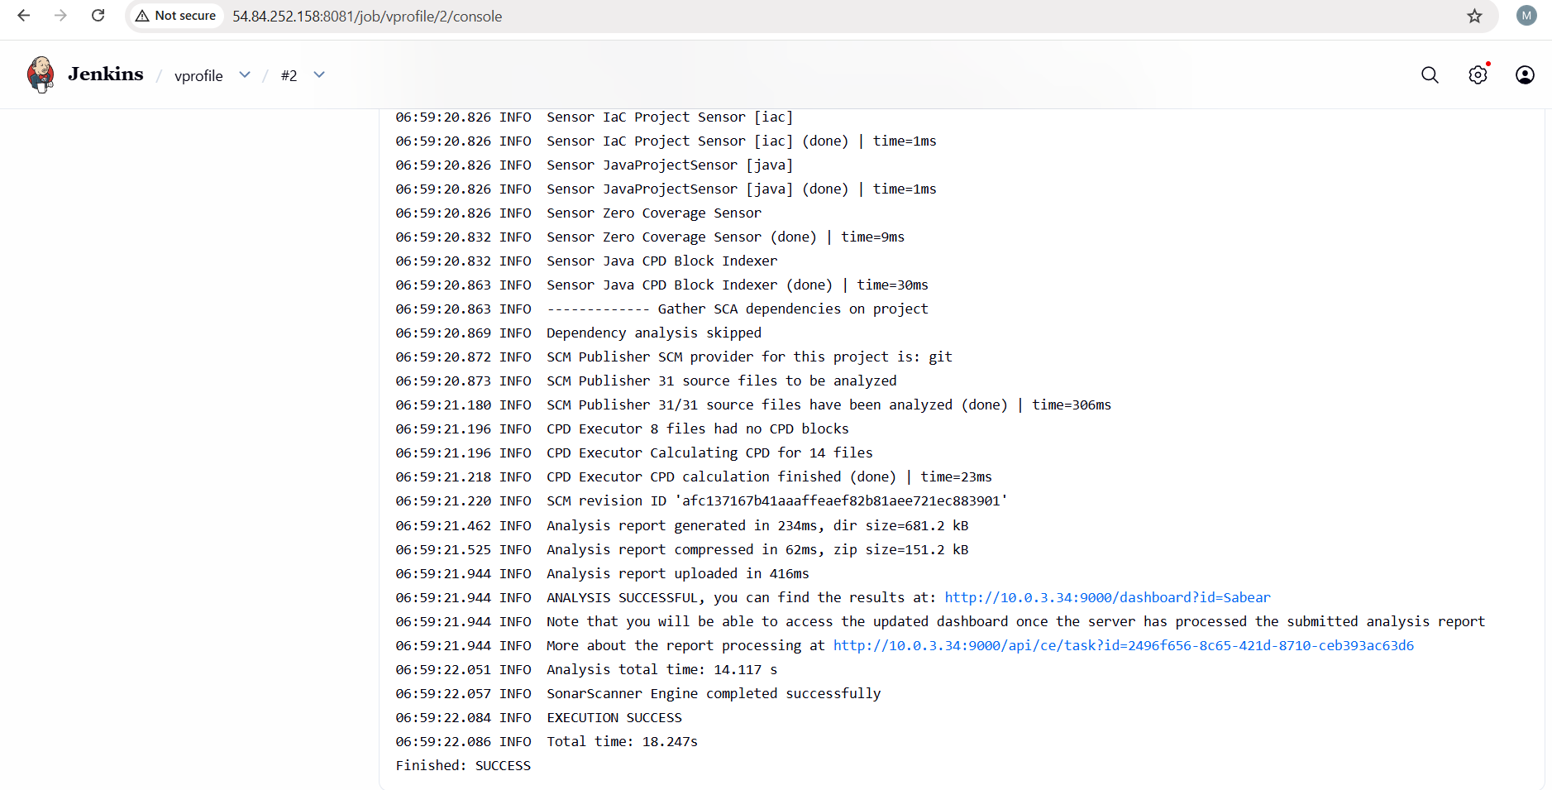
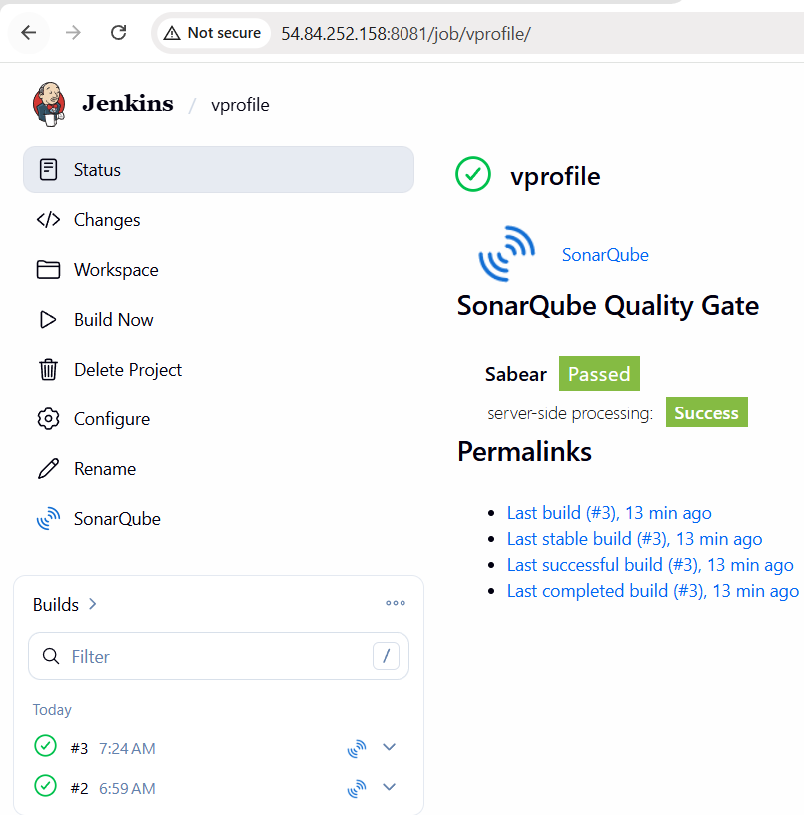

stage3: Slack Integration to send the alerts to slack.

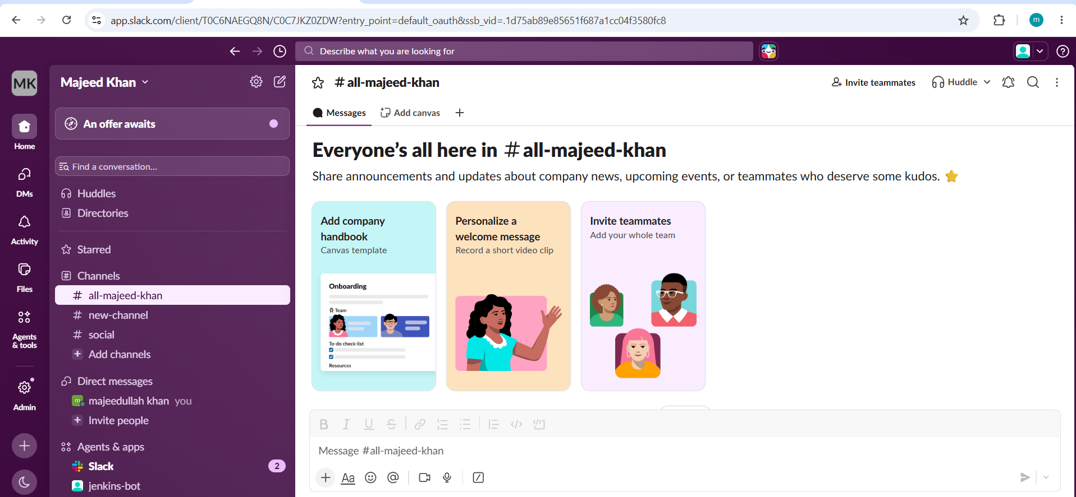
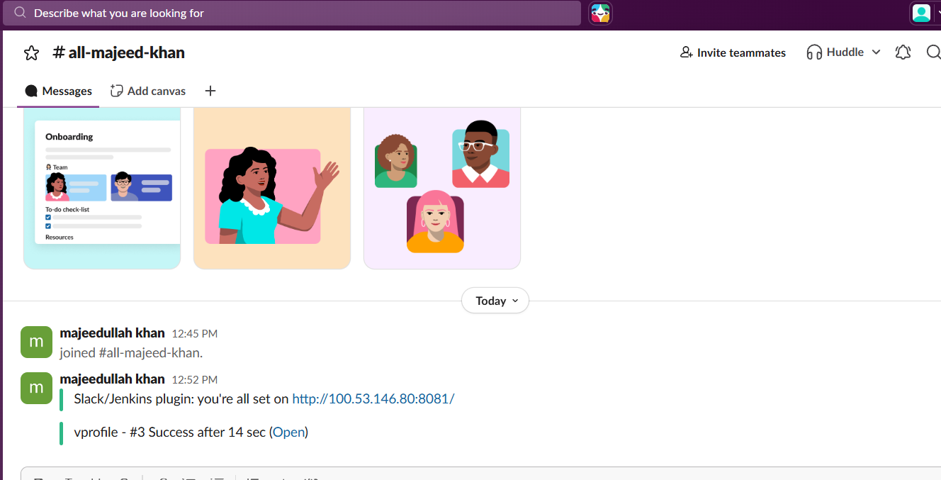
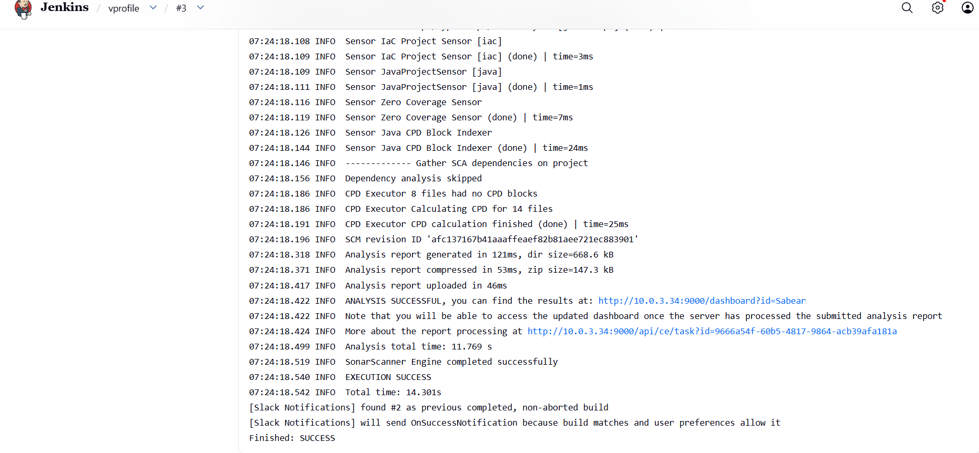

2. Create one Jenkins job using the below code and create three stages.
- stage1: Git clone to download the source code.
- stage2: Sonarqube Integration to check the quality of code.
- stage3: Slack Integration to send the alerts to slack.
Source Code: https://github.com/betawins/hiring-app.git

- stage1: Git clone to download the source code.
Stage 1 — Git Clone
Configuration Steps
- Created a new Freestyle project in Jenkins.
- Job name:
hiring-app
- Opened Configure.
- Under Source Code Management, selected Git.
- Entered the GitHub repository:
https://github.com/betawins/hiring-app.git
- Since the repository is public, selected:
Credentials: - none -
- Configured the branch:
*/main
- Saved the Jenkins job.
- Selected Build Now to test the Git integration.
- Jenkins successfully cloned the repository into:
/var/lib/jenkins/workspace/hiring-app
Verification
The Jenkins console showed:
Cloning repository https://github.com/betawins/hiring-app.git
and:
Checking out Revision 9405b107fdffdf68e69fe953ea1f9669784f9d6a
The build completed with:
Finished: SUCCESS
Observation
- Jenkins successfully connected to the public GitHub repository.
- The main branch was successfully checked out.
- Source code was downloaded into the Jenkins workspace.
- No GitHub credentials were required.
Result
Stage 1 — Git Clone was successfully completed. Jenkins successfully downloaded the hiring-app source code from GitHub and checked out the main branch.

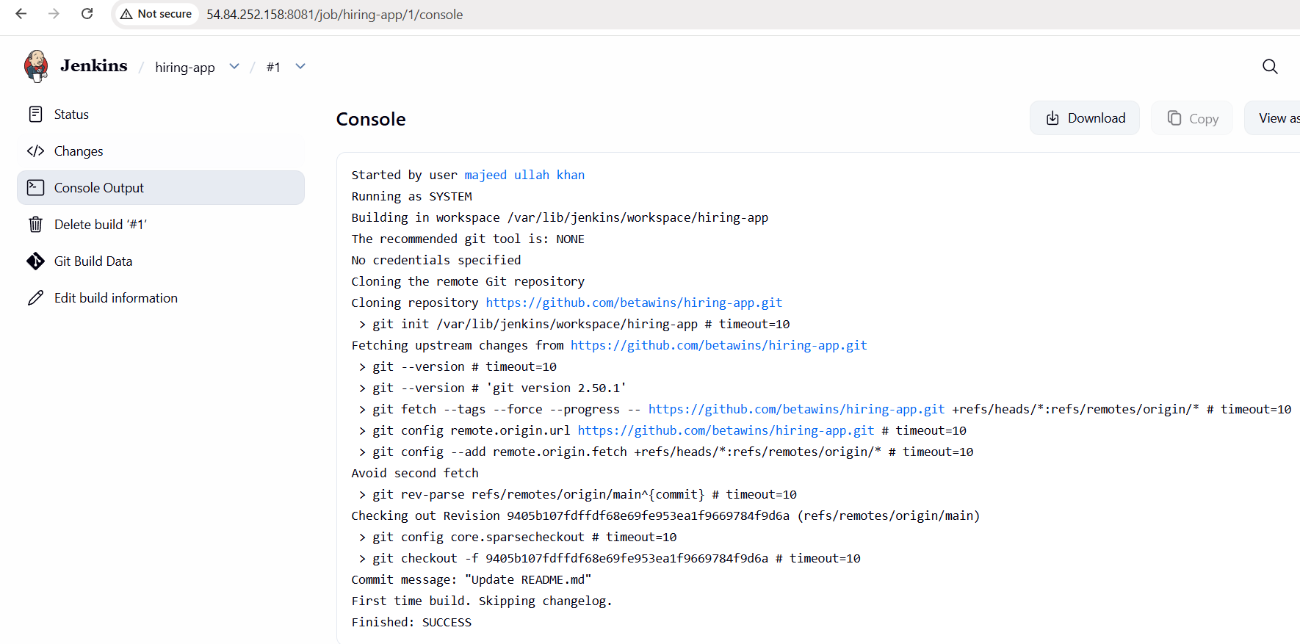

- stage2: Sonarqube Integration to check the quality of code.

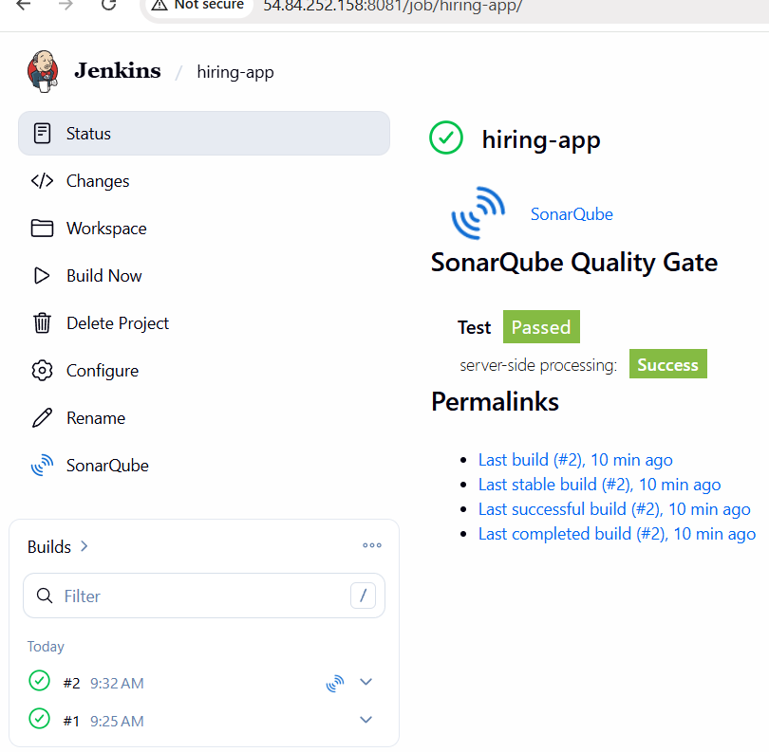
stage3: Slack Integration to send the alerts to slack.
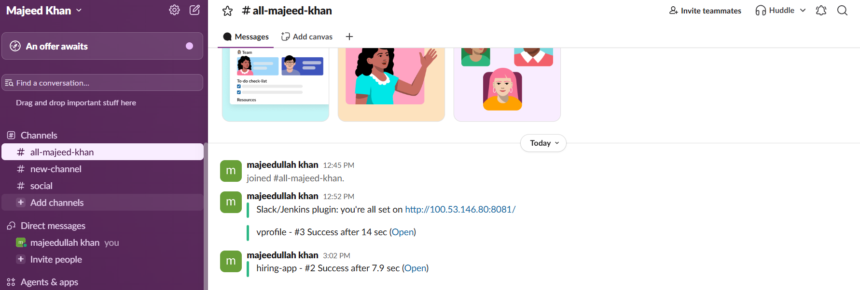
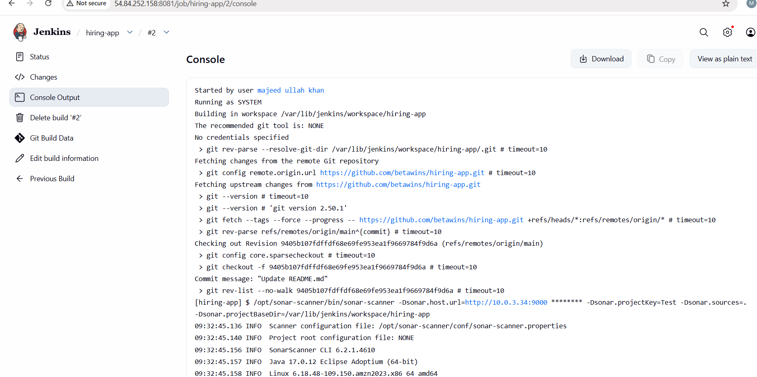

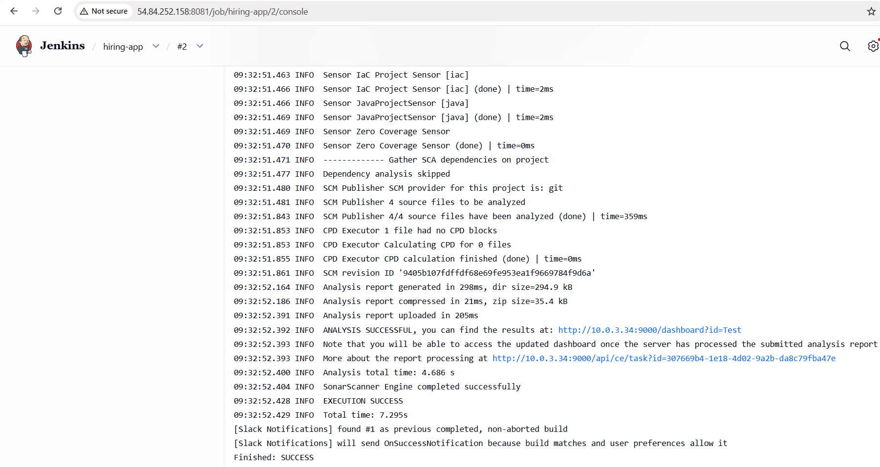

GitHub
↓
Jenkins Freestyle
↓
Git Clone ✅ Stage 1
↓
SonarQube Scanner ✅ Stage 2
↓
Slack Notification ✅ Stage 3

